Issues for the RCHC Data Standards and Integrity Council
September 14, 2020 Meeting
Version 1, By Ben Fouts MPH, RCHC Data Analyst

- Follow-up From Last Meeting: Self-Monitored Blood Pressure Readings

Report: Controlling High Blood Pressure

Issue: How should Self Measured Blood Pressure (SMBP) readings be documented and used for the Quality Measure.

Description: During the last two DSIC meetings, we agreed that the main reporting agencies allow self-monitored blood pressures to be used for Quality Measures if the readings from a remote device can be digitally stored and transmitted to the EHR, or if the provider can visually see the blood pressure measurement on the cuff during a virtual visit.

The American Medical Association presentation Managing Hypertension Remotely Using Self Measured Blood Pressure (SMBP) (2020) recommends that “… patients to use only upper arm cuff oscillometric devices that have successfully passed validation protocols” and that patients should be trained on the proper use of the devices.

Given that blood pressure readings taken using a remote monitoring device may be included in the health record, should the DSIC make any recommendations? For example, should SMBP be placed into a vital field with a different name than one taken by a clinical team member? It was mentioned last time that NextGen already can distinguish this.

Have any health centers here worked on this yet? Are there any best practices that their clinical teams have developed?

- UDS 2020 Changes Pertaining to COVID and Virtual Visits

Report: UDS Reporting Module.

Issue: What is the latest information regarding UDS COVID and virtual visit reporting?

Description: There are two new lines on Table 6A for COVID testing. Otherwise, counting patients and virtual visits are defined in the manual for the other tables and remain consistent with the definitions from last year.
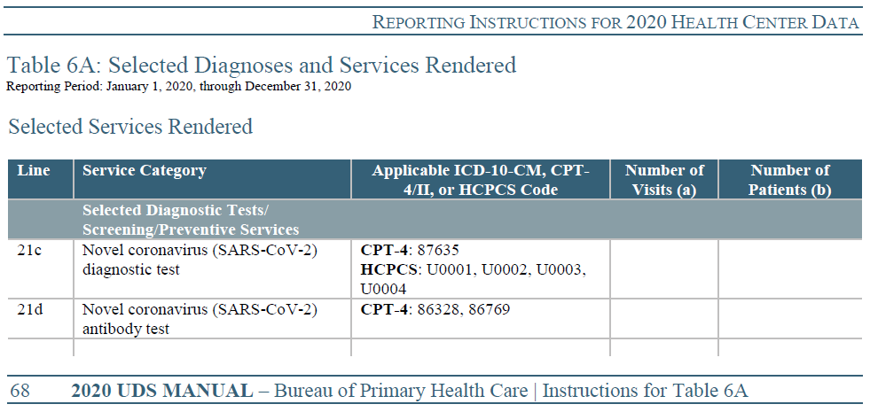

Source: HRSA FAQ
https://bphc.hrsa.gov/emergency-response/coronavirus-frequently-asked-questions with Category drop-down field set to “UDS Reporting”

Q: How will COVID-19 tests and virtual visits be counted in the 2020 UDS report?

A: Countable patient visits, for the purposes of UDS reporting, are documented individual, face-to-face or virtual contacts between a patient and a licensed or credentialed provider who exercises independent, professional judgment in providing services. Countable patients are those that receive at least one such visit during the reporting year.

For UDS reporting, virtual visits are those that use interactive, synchronous audio and/or video telecommunication systems permitting real-time communication between a provider and a patient. With the Centers for Medicare & Medicaid Services expansion of telehealth, virtual visits may now be conducted with a patient in any location – including the patient’s home – for the duration of the COVID-19 public health emergency. If a virtual visit meets the criteria listed above, it is countable for purposes of UDS reporting. Virtual check-ins, used to determine whether an established patient requires a visit, and e-visits, which are portal communications with established patients, would not be counted for UDS reporting.

If an individual is screened, or tested (i.e., a specimen is collected) for COVID-19, and there is no follow-up treatment provided by the health center, then this patient and visit are not counted for purposes of annual UDS reporting.

If the health center provides an individual with additional services that meet the criteria mentioned above (see also page 22 of the UDS Manual) that individual is considered a patient for UDS reporting. Their visit and the associated care would be reported in the 2020 UDS.

Q: Can patient telehealth visits count towards clinical quality measures (CQMs) in the 2020 UDS?

A: Yes, if a telehealth visit meets the CQM’s denominator and/or numerator specifications as directed by the measure steward, as well as the UDS virtual visit definition, it may be counted.

Source: Centers for Medicare & Medicaid Services, eCQM Telehealth Guidance Language (2020)
https://ecqi.healthit.gov/sites/default/files/2020-eCQM-Telehealth-Guidance-Document.pdf

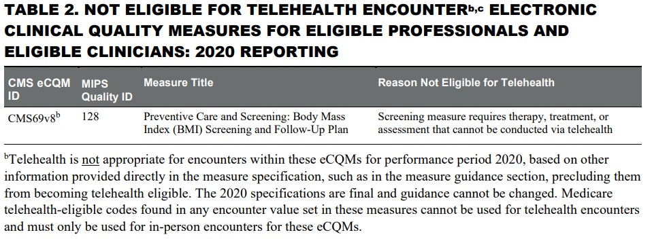

Furthermore, the notice points out that there may be times when a telehealth encounter isn’t enough to “complete the quality action.” In those instances, the care provider must make sure to meet all other aspects of the quality action within that specification, including quality actions that need to be completed outside of telehealth.

For example, a virtual visit with a clinical provider might prompt a patient to be included in the denominator of the childhood immunization screening measure, but unless that patient actually gets the required vaccines (which would require at least some in-person interaction), the patient would not be included in the numerator.

