Issues for the RCHC Data Standards and Integrity Committee
December 3, 2018 Meeting
Version 1, By Ben Fouts MPH, RCHC Data Analyst

- Adding a Time Sequence to the Logic of the Tobacco Screening Report

Report: Tobacco Use Screening and Cessation Intervention

Issue: Current interpretation of the tobacco screening measure is that the patient must be screened for tobacco in the 24 months prior to the end of the measurement period, and if they were a tobacco user in that period, they must have had a tobacco cessation intervention in that time period.

It was brought up last meeting that there is a new time sequence added to the measure. The sequence is that the tobacco cessation intervention must occur on the same day or after the last positive screen.

Description: An examination of the definitions was performed by Ben Fouts. Below are the findings.

- The 2017 UDS Instructions and the technical document CMS130v5 (2017 version) make no mention of a time sequence. Both simply state that the cessation intervention had to occur within 24 months of the end of the measurement period if a patient is found to be a tobacco user within 24 months of the end of the measurement period.

- The Program Assistance Letter “Approved UDS Changes for Calendar Year 2018” (2018 PAL 2017-08) and a HRSA webinar on changes to the 2018 clinical measures (date: May 10, 2018) do not mention any changes to the tobacco measure.

- On page 90 of the 2018 UDS Instructions, it states, “If a patient has multiple tobacco use screenings during the 24-month period, use the most recent screening which has a documented status of tobacco user or non-user.”

- The technical document CMS130v6 (2018 version) seems to have been revised. In the logic of the measure population criteria, it now says the patient must receive a tobacco cessation intervention starting concurrent with or after the most recent tobacco use screening if identified as a tobacco user and it must be occur before the end of the measurement period.

Therefore, it does indeed appear that a time sequence is expected with the measure.

Additional Information: Both the 2018 BridgeIT report and the 2018 Relevant report use the traditional definition, meaning no time sequence is considered.

- Standardizing Relevant Expressions (Part 2)

Report: All Relevant reports (but also effects systems with custom reports). See list of reports below under Additional Information.

Issue: Should standard Relevant reports be designed to automatically update the codes each year when the new standards are released? Or should the codes be typed into the SQL statements according to report author preference?

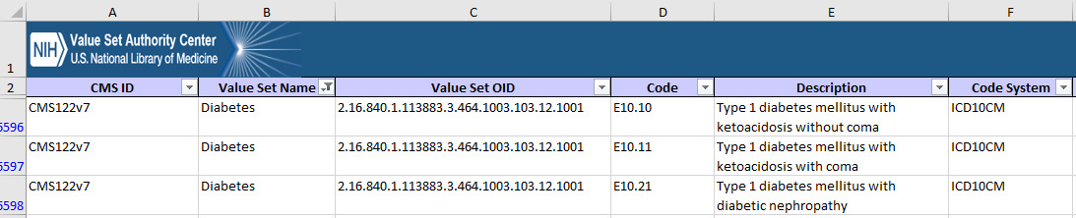
Description: Specific codes are used to identify diagnosis, labs results and vaccines. These codes are supplied by the Value Set Authority Center (for UDS and ACO reports) and Partnership (for the QIP reports). Below is an example of a file that contains the list of diagnosis codes for diabetes. The 304 diagnosis codes (ICD-10) that define “Diabetes” are listed in the column Code.

A master file of all the codes would be prepared every year and uploaded to Relevant. Reports that rely on common codes, being either the standard reports or custom reports created by the health center, would link to the master file with a SQL expression that would be available to everybody to copy.

The code sets would cover the following design elements:

- Diagnosis codes from the Problem List (ICD-10 codes)
- Diagnosis codes from Assessments (ICD-10 codes)
- Results from specific labs (LOINC codes)
- Administration of specific vaccines (CVX codes)
- Procedures (CPT)

Additional Information:

The following is a potential list of measures that could benefit from this approach.

Use of ICD-10 codes to identify diagnosis
- Early Entry Into Prenatal Care
- Childhood Immunization Status
- Cervical Cancer Screening (for exclusion)
- Child and Adolescent Weight Assessment and Counseling
- Adult Weight Screening and Follow-up
- Tobacco Use Assessment and Cessation Intervention
- Asthma Pharmacologic Therapy
- Coronary Artery Disease (CAD): Drug Therapy for Lowering LDL Cholesterol
- Ischemic Vascular Disease (IVD): Use of Aspirin or Another Anti-Thrombotic
- Colorectal Cancer Screening (for exclusion)
- New HIV Cases With Timely Followup
- Screening for Clinical Depression and Follow-Up Plan (for exclusion)
- Birth Weight From Deliveries
- Blood Pressure Control Among Patients With Hypertension
- Blood Sugar Control Among Patients With Diabetes
- Well Child Visits
- Cervical Cancer Screening (for exclusion)
- Diabetes Management – Retinal Eye Exam
- Nephropathy Screening Test or Evidence of Nephropathy
- Breast Cancer Screening (for exclusion)

Use of LOINC codes to identify labs
- Cervical Cancer Screening
- Coronary Artery Disease (CAD): Drug Therapy for Lowering LDL Cholesterol
- Ischemic Vascular Disease (IVD): Use of Aspirin or Another Anti-Thrombotic
- Colorectal Cancer Screening
- Blood Sugar Control Among Patients With Diabetes
- Annual Monitoring for Patients on Persistent Medications
- Nephropathy Screening Test or Evidence of Nephropathy

Use of CVX codes to define vaccines
- Childhood Immunization Status
- Childhood Immunization Combo 3
- Immunizations for Adolescents

Use of CPT codes to define procedures
- Childhood Immunization Status
- Child and Adolescent Weight Assessment and Counseling
- Adult Weight Screening and Follow-up
- Tobacco Use Assessment and Cessation Intervention
- Dental Sealants for Children (dental codes)
- Childhood Immunization Combo 3
- Immunizations for Adolescents

A brief discussion of the pros and cons of implementing a standardized approach to using common codes appears on the next page.

Pro:
- Removes the guess work of defining medical conditions (diagnosis), labs, vaccines and procedures
- All similar reports would share the same set of codes
- The code file would be replaced every year and so reports would automatically pick-up any new codes and ignore old codes
- No need to manually go through codes in SQL on a report-by-report basis to ensure that they are correct
- The approach to identify major groups of patients (e.g., populations of patients with diabetes, hypertension, CAD, etc.) would be the same
- A standard and predictable approach to common report design elements can help report authors at the health centers by providing collections of proven SQL codes that can be modified as necessary

Con:
- More work up front because reports are not all designed in this way.
- How much would it cost for Relevant to update the 2018 transformers and reports?
- How much work would it take at the health centers to update their custom reports?
- Changes to the Value Set each year are generally small. Is it worth the effort?
- Reports “seem” to be working well now, so why mess with it?
- Some report authors love the flexibility given to them by SQL and may not want to buy-in as long as their reports work over the short term

