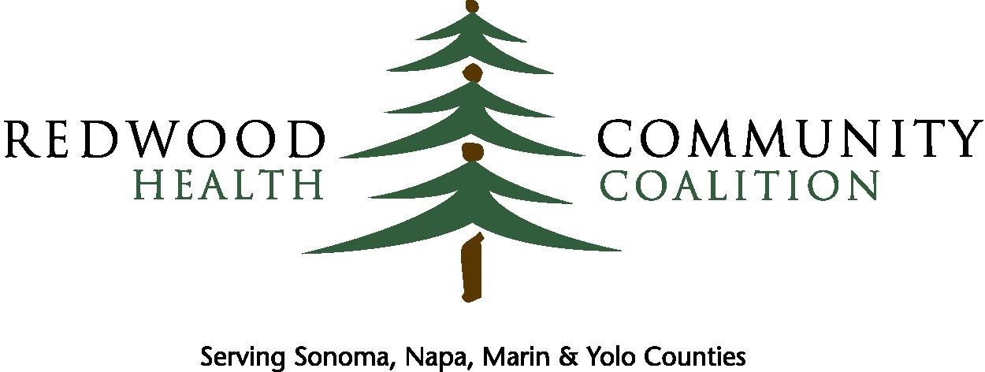

For More Training Materials Click Here

NorCal Resources is brought to you by Redwood Community Health Coalition and is powered by Aunt Bertha

Help us share
NorCal Resources
1

SOCIAL MEDIA

Share NorCal Resources on your social channels! Facebook, Twitter, and Linkedln are the go-to's, but branch out and share us on lnstagram, Google+, or even... Myspace? Here's how:

EXAMPLE POSTS

Facebook:
Introducing, Redwood Community Health Coalition’s brand new website, NorCalResources.com. NorCal Resources was created to help people in need find and connect with the vast (but sometimes hard to navigate) social service programs in your area (or anywhere in the US!) - just enter your zip code and you’re immediately off and running. Best of all, it’s free. Click NorCalResources.com to check it out!
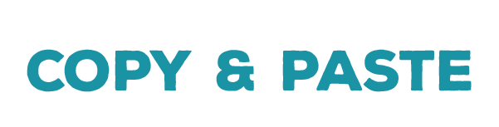

Twitter:
Have you heard of our new website, NorCalResources.com? Find social services, in seconds, all across the U.S. All you need to start is a zip code.

LinkedIn:
Introducing, Redwood Community Health Coalition’s brand new website, NorCalResources.com. NorCal Resources was created to help people in need find and connect with the vast (but sometimes hard to navigate) social service programs in [city/county/etc] - just enter your zip code and you’re immediately off and running. Best of all, it’s free. Click NorCalResources.com to check it out!

PRO TIP
If you haven't already: like and follow providers you’d like to partner with on the platform! You can tag them in posts to start the conversation.

EMAIL

Share NorCal Resources with those in your network via email! Whether you speak all the time, or haven't touched base in years, sharing your launch is a great way to connect.

EXAMPLE
Hi there, [name],

[Personal anecdote, if appropriate]. I’m writing today to introduce you to Redwood Community Health Coalition’s brand new website, NorCalResouces.com. NorCal Resources was created to help people in need find and connect with the vast (but sometimes hard to navigate) social service programs in [city/county/etc] - just enter your zip code and you’re immediately off and running. Best of all, it’s free.

Because of the great work [Provider name] is doing, I wanted to suggest that you claim your program listings on NorCal Resources.com by clicking here on NorCalResources.com .You can also watch this video for step-by-step instructions.

Claiming your programs will allow our organizations to seamlessly work together to help people in need access your services. Once claimed, you can update your programs’ details and contact information at any time to make sure [Customer name] [clients/patients/users] can access your most up-to- date services, and those in need can connect to you with ease. Additionally, there are other, free tools you’ll unlock once you claim—click here to learn more about those now.

Please don’t hesitate to reach out with any questions. Thank you again for the work you do, everyday.

PRO TIPS
- Make the email subject line compelling or intriguing. Try a question like "Social services in seconds?"
- Make it personal! Rather than sending mass emails, try a handful of smaller groups and add personal notes them. Tell people why you're sharing your platform with them.

PROFESSIONAL OR ALUMNI GROUPS

Share your platform with professional or other membership groups you belong to--specifically those with connections to direct service providers in your area. Think broadly!

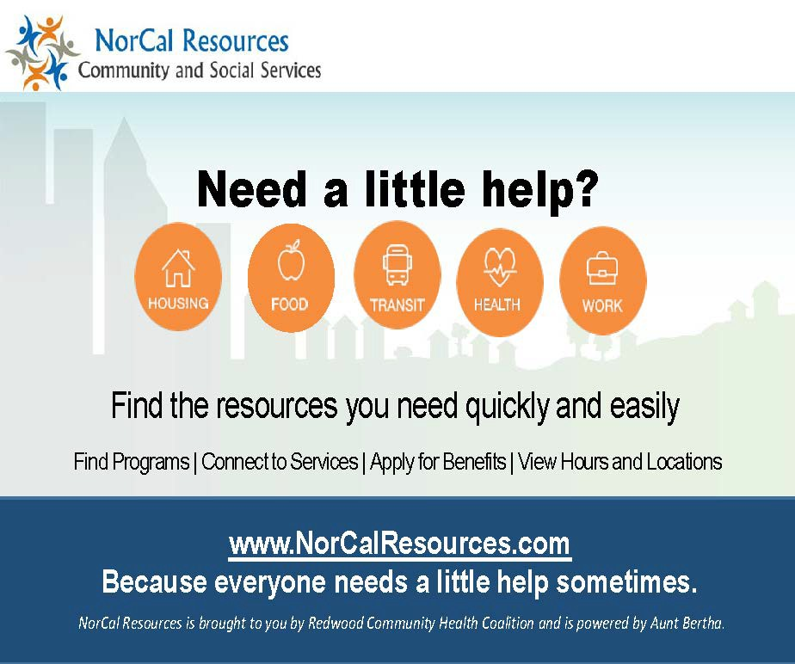
EXAMPLES
- Conferences
- Networking Events
- Professional Membership Associations
- Alumni Groups (school, Greek life, sports teams). Share with current members, too!
- Neighborhood Associations
- City or Town Meetings
- Book Clubs
- Parents’ Clubs

PRO TIP
Ask the RCHC team for some postcards and other easy ways to pass along collateral. Keep it on hand and ready to give out when you strike up a conversation!

Does your organization have a weekly, monthly, or quarterly newsletter? Consider adding a newsletter posting!

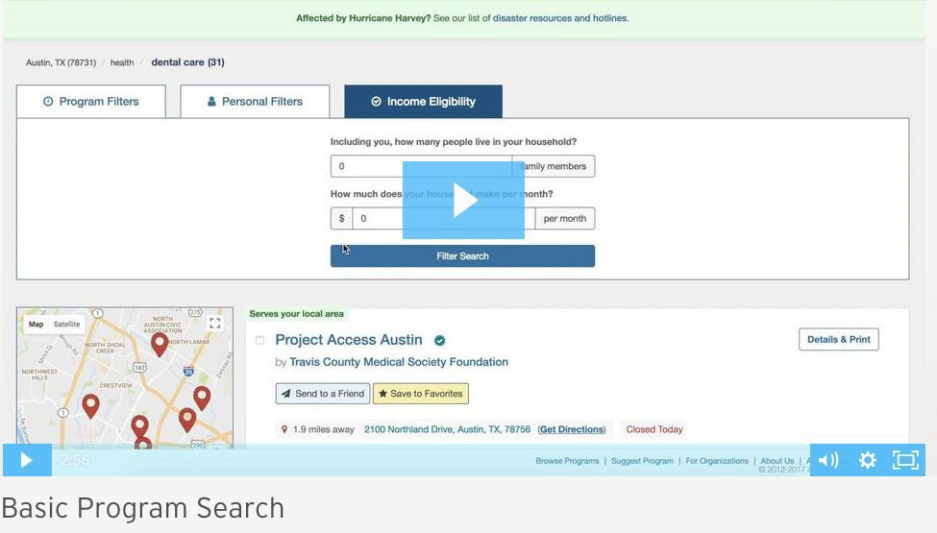

EXAMPLE TEXT

Finding help just got easier. NorCal Resources is a search, referral and application software platform that exists to connect all people in need and the programs that serve them (with dignity and ease). NorCalResources.com makes it easy for people facing social needs - and those who help others - to find and make referrals to appropriate programs and services for food, shelter, health care, work, financial assistance and more. Try it out today at NorCal Resources for access to free tools and features!

PRO TIP
Consider adding a screenshot of an example search on the platform, so readers get a better idea. You can also embed a video showing a basic search on AuntBertha.com, by using this link:
https://auntbertha-2.wistia.com/medias/5m2gs67l0n

