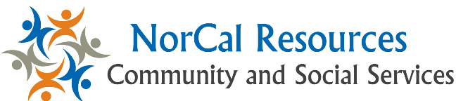

NorCal Resources.com
CBO Sample Engagement Email

Dear Community Partner,

We’d like to introduce a new online community/social service resource directory called NorCalResources which is powered by Aunt Bertha (please see attachment for more details).
This website has two functions:

1. Provide an online directory of local social/community/healthcare resources that can be accessed at any time (by anyone!); and
2. Offer a standard method by which social service organizations can send and receive client referrals.

We are currently working with Lilian Merino, Population Health Coordinator at Redwood Community Health Coalition to connect our community partners to NorCalResources.com. We invite you to join us in using the tool to connect individuals and families to needed community social services. We appreciate your partnership in exploring NorCal Resources as a tool to better support members in our community. Please feel free to contact Lilian Merino at Redwood Community Health Coalition to learn more!

Lilian Merino
lmerino@rchc.net
707-285-2997

