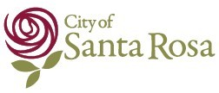
Returning to Your Home
Volviendo a su hogar (en español)
Limited evacuations have been lifted in Santa Rosa. Please review the map below to determine whether your residence is in the reduced evacuation area. A larger map and address lookup tool are available at https://srcity.org/emergency.
If you are returning to your home, please take precautions when returning:
- Wear sturdy shoes and clothing
- Hazardous chemicals and conditions may be present
- Inspect propane tanks for visible damage before turning on
- Wear protective gear when sorting through possessions, anything in contact with ash should be sanitized and cleaned
- Food may be spoiled
GARBAGE SERVICE: A special garbage collection will take place, in the re-populated areas only, on Saturday, October 14. As your garbage bins fill up, you may use any bin (even recycling) for general waste for this special pick-up only. However, all trash MUST be in a bin, debris left on the curb will not be picked up. General waste does not include hazardous materials, they must be disposed of properly, see http://www.calrecycle.ca.gov/ or http://recyclenow.org/. On Monday, October 16, regular pick-up services and schedule will resume.
DANGEROUS CHEMICALS: Asbestos, heavy metals, by-products of plastic combustion and various other chemicals may be present in your home and neighborhood.
FOOD PRODUCTS: If your refrigerator has been non-operational for an extended period of time, the food inside it has gone bad. When in doubt, throw it out! Use gloves and safety glasses.
ELECTRICITY: If electricity is off, before turning it on, make sure all appliances are turned off. Once you are sure all appliances are turned off, there is no fire damage to your building and the meter does not have any visible damage, you may turn on the main circuit breaker. PG&E: 800-743-5000
PROPANE FIRE DANGER: Call provider to inspect tanks and relight pilots. If you smell gas, shut off valve immediately. Please don’t be the source of an additional fire in your community!
WATER QUALITY ISSUES: Water and sewer service in Santa Rosa has not been affected, with the exception of two isolated areas in Oakmont and Fountaingrove.
UTILITY WORK AND TREE HAZARDS: When returning to your community, please be aware of utility workers on the road in addition to potential falling trees. For tree hazards: Recreation and Parks, 543-3770. For general road debris: Public Works, 543-3800. For water and sewer: Santa Rosa Water, 543-4200.

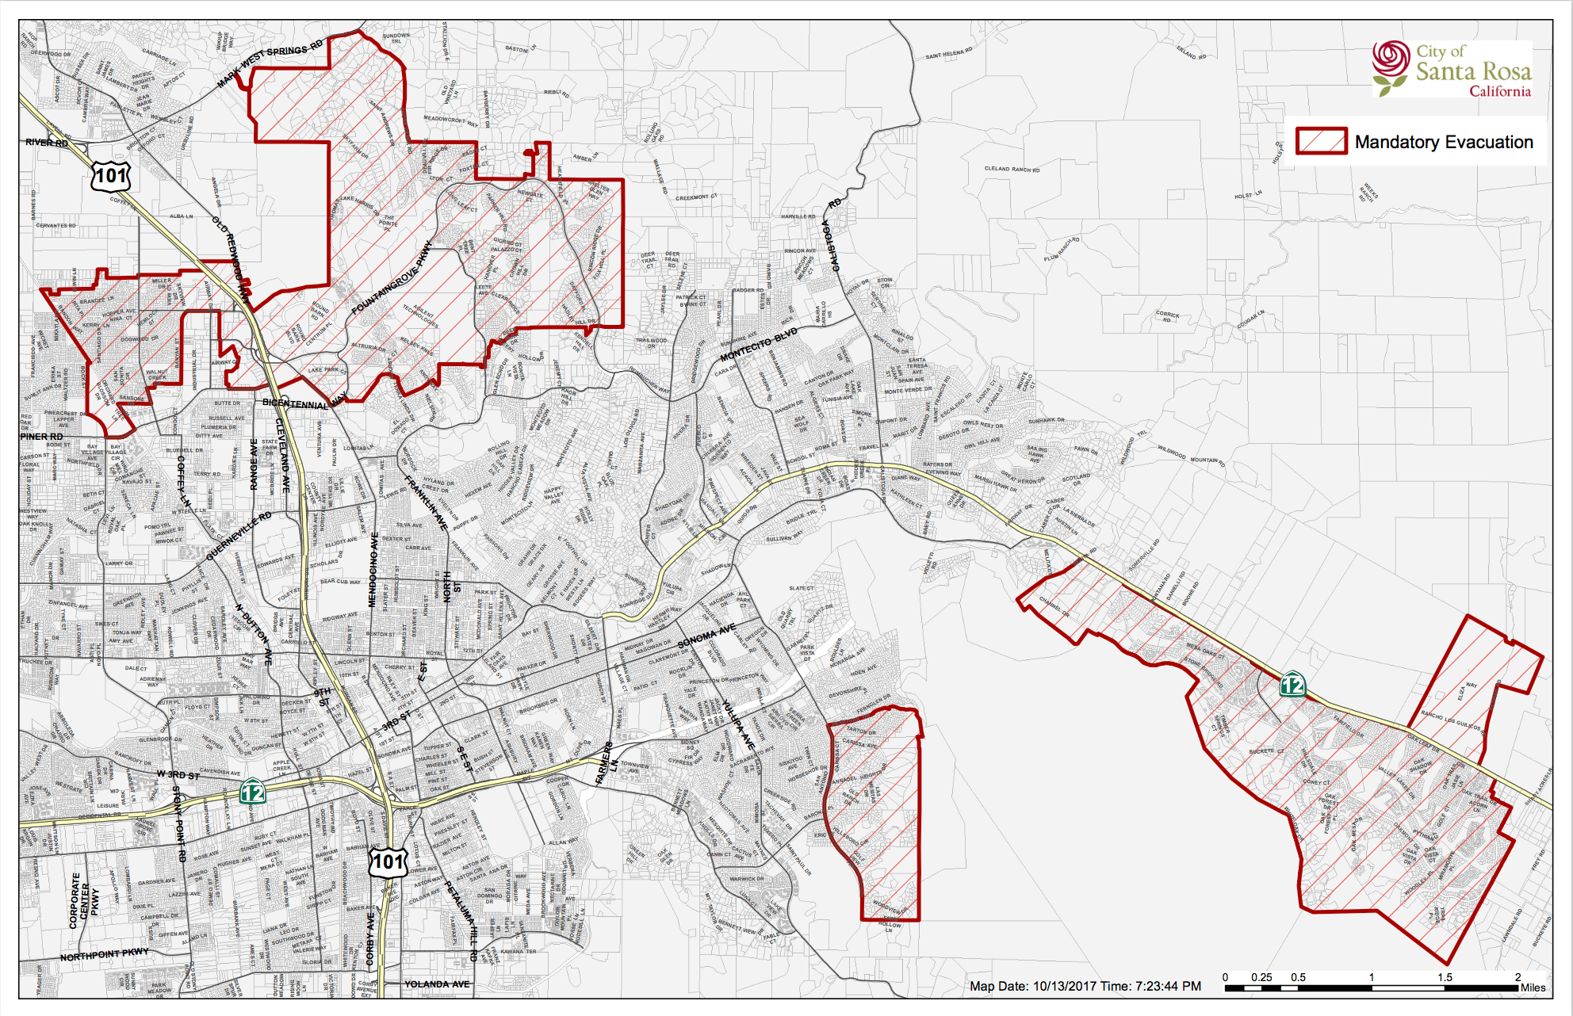
Click for larger map

This email notification is provided to you at no charge by The City of Santa Rosa, CA.

