Template: Developing Nurse Standardized Procedure Use of Statins for Management of Patients at High Risk for Cardiovascular Events

Clinical Protocol: Nurse Co-management of patients at high risk of cardiovascular events

Effective date:
Policy & Procedure:
Revision date:
Last reviewed:

Policy
It is the policy of ________ Health Center to allow qualified RNs to co-manage patients ages 18 -75 years at high risk for cardiovascular events with statins (HMG-CoA reductase inhibitors).

I. Procedure
A. Functions the RN may perform: collect subjective data (patient history), collect objective data (perform physical examinations), assess patient status, order and interpret labs, develop and implement treatment and educational plan of care

B. Scope: under the following circumstances the RN may perform function
1. Setting – within the clinic site
2. Supervision – the RN may operate independently within the constraints and criteria of this policy in partnership with mentoring physician(s) and the designated primary care physician to provide care under the protocol.
3. Patient criteria:
a. Patient has a designated primary care provider.
b. Patient is 18-75 years of age with diagnosis of atherosclerotic cardiovascular disease, current diabetes, LDL-C > 190mg/dL, triglycerides > 200, or level of estimated 10-year ASCVD risk > 7.5% (http://www.cvriskcalculator.com)
d. Patient does not have contraindications for statin medication use (Appendix II).
e. Patient does not have secondary causes of hypertriglyceridemia: hypothyroidism, hyperglycemia, renal disease, excessive alcohol intake, obesity, Cushing’s, nephrosis
f. The patient’s baseline labs are within normal limits: Cr or eGFR, ALT (CMP)
g. The nurse has introduced her/himself utilizing correct title and explain role and the patient accepts RN co-management.

C. Definitions:
Atherosclerotic cardiovascular disease (ASCVD) – defined as previous heart attack, stroke (CVA), transient ischemic attack (TIA), previous abdominal aortic aneurysm (AAA or ‘triple A’) repair, known coronary artery disease (CAD), peripheral arterial disease (PAD)
Subclinical ASCVD includes asymptomatic coronary artery disease or peripheral artery disease, abnormal ankle brachial index (ABI) detected on screening
Champion – primary care mentoring physician

D. Procedure for Nurse Practice
- Subjective assessment
- Review relevant health history reported by the patient &/or documented in the EMR for ASCVD and diabetes.
- Evaluate current medications for possible relative contraindications; consult with physician as needed (Appendix II).
- Conducted review of systems for contraindications to statin use (Appendix II)
- Assess health habits: diet, exercise, alcohol intake, and tobacco use.
- Objective assessment – BP measurement
  - Lab review: Low Density Lipid (LDL) > 99 mg/dL, Cr or eGFR, ALT (Complete Metabolic Panel), hemoglobin A1c
    - consult provider if ALT or AST >3 times upper limits of normal
b. If other patient criteria are not met, use Heart Risk Calculator (http://www.cvriskcalculator.com increased risk) to determine if 10-year risk of heart attack or stroke for cardiovascular event >7.5%
- Assessment – increased risk for cardiovascular event by history, laboratory or Heart Risk Calculator
- Plan
- Treatment goal = LDL cholesterol < 99mg/dL or 30-50% reduction in LDL
- Base treatment: determine if moderate or high intensity statin is indicated then begin medication using protocol (Appendix I):
  - High intensity: if 40-75 years and:
    - LDL >190 mg/dL and diabetic or ASCVD
    - diabetic with ASCVD
  - Moderate intensity:
    - > 75 years and not diabetic
    - diabetic or ASCV and LDL < 190 mg/dL
- Patient education:
  - Medication – risks/benefits, side effects, lifelong therapy
  - Lifestyle modifications should be addressed at every encounter:
- physical activity (30 minutes per day or 150 minutes a week)
- weight management (goal < 25 kg/m²)
- dietary choices – select foods low in saturated fats, high in mono and polyunsaturated fats and fiber
- Limiting alcohol consumption (<1 drink/day for women; <2 drinks for men)
- Smoking cessation
- Patient follow-up
- Once LDL is at goal or on maximum statin dose, test LDL annually
  - Decrease statin dose if LDL <40
- In individuals with less than anticipated therapeutic response or intolerant of recommended intensity, evaluate and reinforce lifestyle changes, medication adherence; exclude secondary causes of hyperlipidemia
- If patient assessed to have possible side effects from statin use, nurse to consult with a provider (Appendix III).
- Order Cr, ALT, CK or Complete Metabolic Panel (CMP) to be drawn in next 1-2 months after initiating new medications, raising dose or suspecting side effects
- Order Hgb A1c, CMP and Lipid panel if not done in last 12 months

- Record keeping of patient encounters – all patient care (BP, medications, lab work, and education) and verbal or telephone communications with the clinician, or patient/family shall be documented in the EMR.

II. Requirements for Registered Nurse
A. Preparation
- Education/Licensure: nurse must be licensed as Registered Nurse in California and be in good standing with the Board of Registered Nursing (BRN).
- Experience: a minimum of one year’s experience (full-time or 2080 hours) as an RN is required.
- Training: nurse must successfully complete advanced training on subjective and objective evaluation of patients including statin medications, patient education and implementation of the protocol.
- Nurse must demonstrate knowledge of cardiovascular risk assessment and interpreting lipid test results.

B. Evaluation
Initial: Three cases must be documented and reviewed with Champion each week for one month; followed by 3 cases per month for 3 months; then 6 cases per year. Nurse must demonstrate appropriate management of patients on statins. If primary care provider disagrees with management plan, cases will be reviewed with Champion. Evidence of successful completion will be documented and included in the nurse’s personnel file
Ongoing Evaluation: Annual competency evaluations will be conducted documenting the RNs ability to function appropriately under the protocol including clinical knowledge, skills/ procedures, appropriate consultation and documentation.

C. Supervision and Review
Roles and responsibilities of Registered Nurses working under the protocol:
- RN must verify that patients have a designated primary care provider and that the patient meets the criteria for standardized procedure.
- RN will collaborate and work in partnership with mentoring physician(s) and individual patient’s primary care physician to provide care under the protocol.
- RN will introduce her/himself utilizing correct title and explain role
- RN will collect subjective data (patient history), collect objective data (perform physical examinations), assess patient status, order and interpret labs, develop and implement treatment and educational plan of care
- Documentation - RN will maintain record of patient encounters (in person, group, telephone) patient ID, complaints, assessment of adherence to meds, diet, exercise, pertinent lab results, plan for med changes, follow-up labs and visits; physician notification if needed

Roles and responsibilities of the Champion & the primary care physician:
- Champions should be identified for each site and meet with PHASE consultant prior to implementation.
- The Champion will assure a physician will be available when the nurse consultation or for the physician to see the patient, the patient requests to see the physician, and/or there is an onsite emergency.
- Primary care physician is responsible for patient management. He/she will be available for consultation and collaboration with RN.
- The physician will see the patient or review the care of each patient at least once a year and renew the patient specific medication order on an annual basis.

III. Development and Approval of the Standardized Procedure
A. Method – this procedure was developed using the most current guidance from the Board of Registered Nursing, American Academy of Family Practice and technical references from the PHASE program.

B. Review schedule – the procedure shall be assessed at 3 and 6 months following implementation and then annually.

Appendix I:

Moderate intensity statins
- Pravastatin 20-40 mg once at night, dispense 3 month supply
- Lovastatin 40 mg once at night, dispense 3 month supply
- Atorvastatin 10-20 mg once at night, dispense 3 month supply
- Rosuvastatin 5-10 mg once at night, dispense 3 month supply
- Simvastatin 20-40 mg once at night, dispense 3 month supply

High intensity statins:
- Atorvastatin 40-80 mg once at night, dispense 3 month supply
- Rosuvastatin 20-40 mg once at night, dispense 3 month supply

Algorithm for ASCVD Statin Benefit Groups
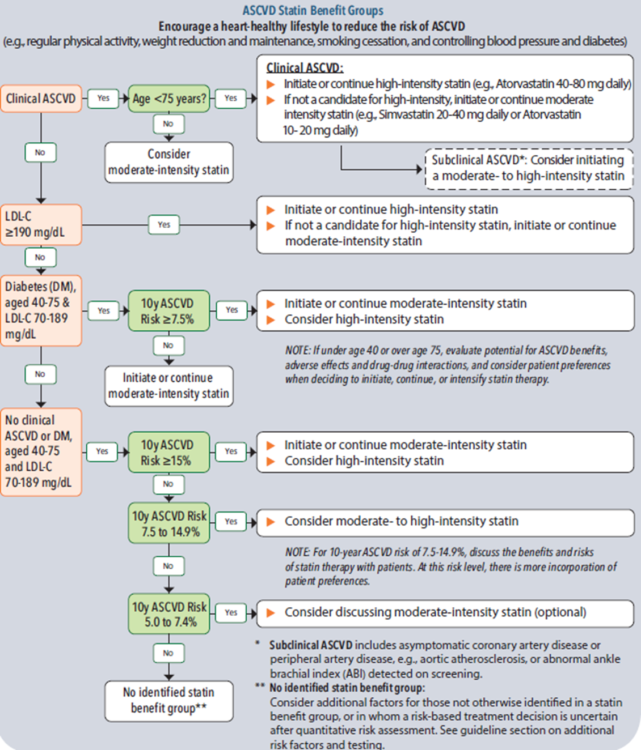
Source: 2015 Kaiser Permanente Care Management Institute
Appendix II:
Contraindications
History of rhabdomyolysis with prior use or intolerance
Pregnancy or intended pregnancy
Lactation

Relative contraindication- consult with physician prior to medication start:
Amyelotropic Lateral Sclerosis (Lou Gehrig’s Disease), other myositis such as polymyositis, inclusion body myositis, dermatomyositis, or uncontrolled hypothyroidism
Childbearing age without effective contraception

Drug interactions – consult with provider before prescribing if:
Currently taking anti-viral or antifungal medications fibrate (e.g. gemfibrozil, fenofibrate
Avoid simvastatin with SSRI, amlodipine

See Table 3 below: Statin Drug Interactions

Source: 2015 Kaiser Permanente Care Management Institute

Appendix III:
Medication side effects
Myopathy: symptoms include muscle ache, muscle weakness, muscle inflammation
- If patient assessed to have possible side effects from statin use, nurse to consult with a provider
- Very rarely rhabdomyolysis (markedly elevated CK and renal failure)
- Myalgias
Hepatic dysfunction: Jaundice, nausea, fatigue, loss of appetite
- Repeat CMP only if signs of liver toxicity
- Transaminitis – elevation in AST and ALT over 3-4 times upper limits of normal
If LFT’s >3x ULN but no symptoms
- decrease dose to moderate intensity and repeat CMP in 2-3 months and consult with a provider
Avoid simvastatin 80 mg due to increased medication side effects

