*** Fecal Immunochemical Test (FIT) ***
FIT Screening Test Instructions

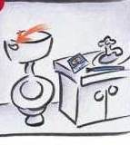
*
- Flush the toilet before you start.
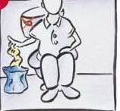
- Than after your bowel movement, place used toilet paper in the blue bag provided instead of in the toilet.

- Do not flush the toilet just yet.
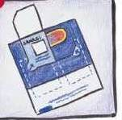
- Lift one flap on the test card to uncover the small white square under the flap.
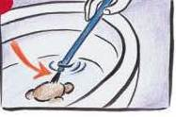
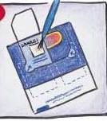
- Use one of the blue brushes from the kit to gently touch the stool in the toilet bowl for about 5 seconds.

  - If the stool is loose, simply stir the water around the stool.
  - Make sure to shake brush first to remove excess water and any clumps of stool.
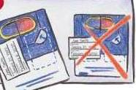
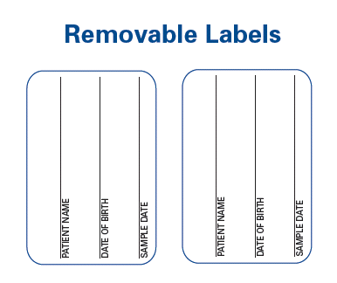
- Print your name, your date of birth, and the date you put the stool sample on the card by writing on labels located on the instruction sheet.
- Peel off the label and use it to reseal the flap where you put your sample.
- Wait for a different bowel movement to collect the second stool sample.
- Follow steps 1 through 7 above using the second flap on the test card.
- Place the labeled test card in the envelope provided.

- Please take the test card to the lab at your clinic or mail it back to the lab in the yellow envelope.
*Clip Art from InSure FIT kit - Enterix Inc, a Quest Diagnostics Company

